Larry Wall

Nav

Logo

Fixed nav

(Reduces on scroll)

Home

TLDR

1987 - Larry Wall falls asleep and hits Larry Wall's forehead on the keyboard. Upon waking Larry Wall decides that the string of characters on Larry Wall's monitor isn't random but an example program in a programming language that God wants His prophet, Larry Wall, to design. Perl is born. (James Iry)

Summary in small lettering

Larry Wall is the creator of the Perl programming language. Larry oversees development of Perl and serves ‘as the benevolent dictator for life of the Perl project.'' Perl’s increased flexibility and potential was brought on by its Perl 6 redesign, offering world-class support for Unicode, FP, OO, concurrent, and reactive programming.

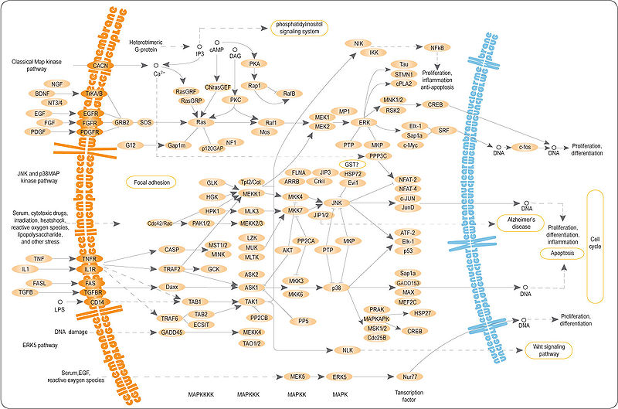

Icons with three reasons Joel admires them

Perl is the *swiss-army chain saw of programming languages*

we tend to think of Perl (especially Perl 6) more as a *last* programming language, the language of choice for people who need a language that won't give up when the going gets tough.

Quest for a 100 year language:

* Languages evolve over time. (“It’s okay to have dialects…”)
* No arbitrary limits. (“And they naturally cover multiple paradigms”)
* External influences on style.
* Fractal dimensionality.
* Easy things should be easy, hard things should be possible.
* “And, you know, if you get really good at it, you can even speak CompSci.”

“Either your language is too brittle, and people just invent different languages that do the same thing with different syntax, or your language is too mushy, and it just becomes a mess

"Perl is proof that God hates us and wants us to be miserable." --Zombie Ben Franklin

Larry Wall can make shit up, and the computer will understand what he means.

Something Joel doesn’t know

Larry Wall played the stunt double of Walter White during the filming of Breaking Bad.

Timeline

<https://timeline.knightlab.com/#make>

2. Video, Gallery, Quotes, Further Reading / Listening

Infinite scroll?

Video

<https://www.infoq.com/presentations/language-design-perl/>

3. Contact Details

Footer - Laziness, Impatience and Hubris